**EXPERIMENT 8**

**Title:** Designing 3D objects using blender.

**Objective:** To design a three-dimensional car using blender.

**Theory:**

Blender is the free and open source 3D creation suite. It supports the entirety of the 3D pipeline—modelling, rigging, animation, simulation, rendering, compositing and motion tracking, video editing and 2D animation pipeline. The latest version can be found on www.blender.org

**Procedure:**

**Step 1:** Open Blender.

**Step 2:** Clear your default interface of blender which includes deletion of cube.

**Step 3:** Go to the mesh and select the image option and set a picture of car as background image in blender.

**Step 4:** Go to mesh and select a cube and cut this cube in half. Now we can use mirror modifier to complete the other half of our car design. With the help of mirror modifier, we can design one side of car and another half will follow accordingly. Also, do check clipping mode in mirror modifier.

**Step 5:** Extrude the cube in the form of rectangular bar which will act as body for our car and do follow the background picture used in Step 3.

**Step 6:** Next, give the cube the almost exact shape of the central portion of the image.

**Step 7:** Go to face select mode and select the upper portion of cube and extrude it a little bit to give it the shape of roof of our car. And extrude from the slide to give it a little slant for more realistic view.

**Step 8:** Now, to design the wheels of car, go to shapes and partition and put them across the car body and give them a good circular shape in form of a wheel. Select all the sides except the area consisting of wheels. Now, go to top view and extrude the whole body sidewise, which will give us a good shape of the body with space for wheels.

**Step 9:** Move all the edges a little bit inwards to give a more realistic view to the car. And next, move the front view of the car in the middle slightly to give it space for headlights.

**Step 10:** Now look at the background picture and extrude from all sides where it is needed to provide a great real view accordingly.

**Step 11:** Go to central portion of wheel area and go to mesh and select a circle. Go to circle setting and change it to 16 vertices and now hit R-90. Select the circle and extrude along x axis to give a real view for the thickness of the tyres.

**Step 12:** Hit E and scale it down to give the rims of tyre a great real view. Now press S and scale the tyres a little bit outward to give a slight bulge to it. Now, select the alternate of 16 vertices and give it a slight extrude and designing for real nice-looking view for tyres.

**Step 13:** Duplicate the same tyre by pressing, press L and press D to duplicate the tyre and press G and Y to move the front tyre to back side and fix it in the centre.

**Step 14:** Add review mirrors by extruding the surface of the car side wise and move it towards the driver and tilt it a bit down.

**Step 15:** Now for the colouring part, go into the edit mode again, and select the faces you want for one colour, and click the + button in the materials section.

**Step 16:** This will apply the colour to all faces, next click on another face, click the + button, and click Assign, this will give the selected face the new material.

**Step 17:** Finally, export this project as .blend file. Also, render a few images for the reference purpose.

**Screenshots:**

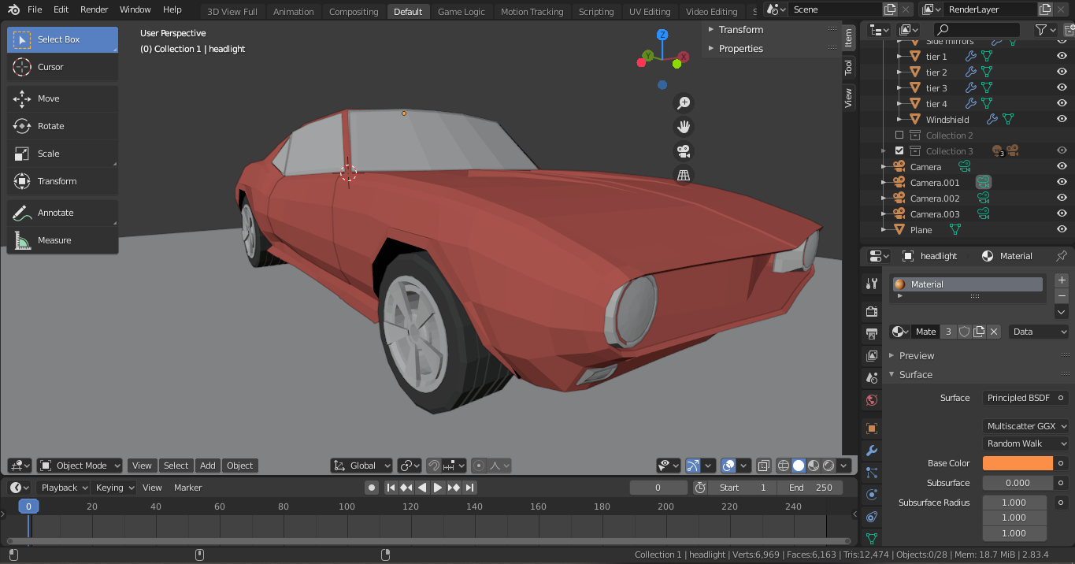

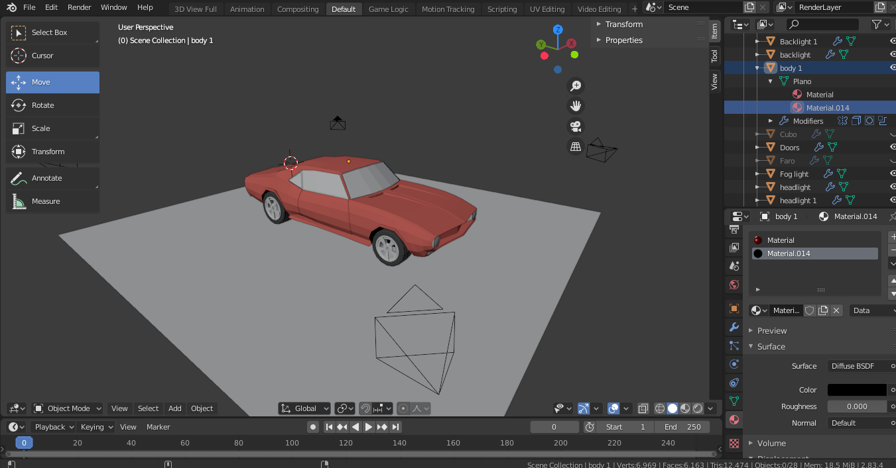

**Link:** [GAT Lab - Experiment 8 (All Files)](https://drive.google.com/drive/folders/1G6oqKeyo6eZ-F9WN3lkJp1JIyfxqso51?usp=sharing)

**Conclusion:** Hence, we have designed an attractive 3D model of a car.